**Manual for Parallel Computing in Python**

Introduction

With the rapid increase of multicore processors, each core with its own supply of threads, the ability to parallelize code has become a necessary tool to any aspiring developer. This manual seeks to convey the knowledge of how to utilize parallel programming using the standard Python 3.9 modules. Parallel computing or parallel programming is a type of computing architecture in which several processors execute an application or computation simultaneously. (1) This “parallelizing” of the code allows for more complex applications and/or a greater amount of computational power than can be accomplished with a single thread of code execution.

**SECTION 2: DETAIL ABOUT THREADS, PROCESSES. WHO IS INTENDED AUDIENCE**

Intended Audience

This manual assumes that the reader has prior programming experience and a familiarity with Python. Having said this, there are some topics that should be summarized before beginning with the procedure. To reiterate, parallel computing is a type of programming that utilizes multiple sequences of code execution simultaneously to perform more machine instructions. In regards to this text, a thread is a single sequence of instructions that can be managed independently. The majority of projects that a beginning programmer studies are done with a single thread and can be considered serial programs. In addition to this, a process is an instance that is being executed by one or more threads. Multi-processing is as its name implies, the ability to access multiple processes each with their own supply of threads to execute instructions within an application. With this knowledge, the progression from lowest complexity to highest for parallel programming is: serial process, multi-threaded process, multi-process application.

NOTE: (Add section about GIL here?)

**SECTION 3: PROCEDURE FOR PARALLELIZING CODE**

Preface

This section will go into detail on a general approach to parallelizing an I/O bound or CPU bound process using Python and its standard modules. The examples used may have modules that are not included with the current version of Python(Python 3.9.0) used by this manual. This text will include one example of an I/O bound process and one example of a CPU bound process.

1. To begin parallelizing I/O and CPU bound programs, you must first determine the “driver” function. This “driver” function is the function that will be performing the specific instructions that we want to parallelize. This function typically will be called many times by the program that you are working with.
2. Once you have determined the driver function, you must then process the input that is being fed to the function. You must partition the data appropriately in order to parallelize the code correctly. The easiest way to accomplish this is to create a list object with all of your data stored inside.
3. After the list object is created, we can then begin operating over the list object with a simple for loop which will pass this data into the executor object which will parallelize the program.

Example using the concurrent.futures module:

This program’s purpose is to download a series of text files from the website <https://www.sec.gov/Archives/edgar/data/20>. It accomplishes this by parsing through the HTML code of the given URL and building a list of string objects named “links” which is filled with the URLs of all of the subdirectories contained within. This is implemented by a function named “parseDirectory” which takes a list for its single argument.

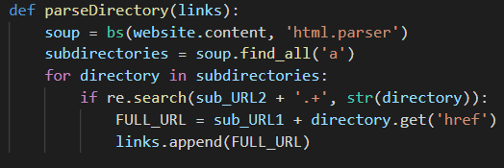

This list of links is then passed into the driver function named “download”.

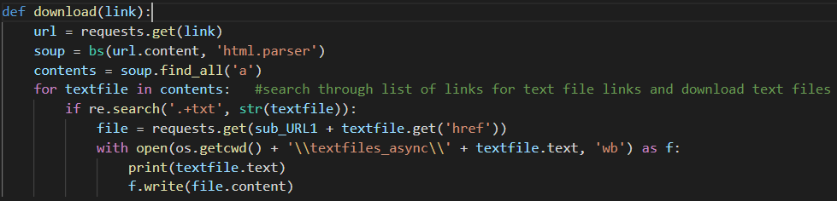

This function takes in a singular link(string) as its argument in order to coordinate with Python’s process pool executor.

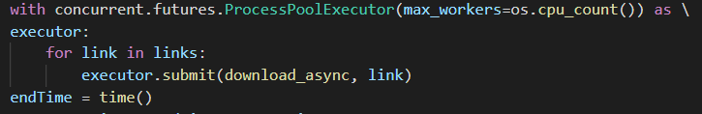

**SECTION 4: CONCLUSION**

Parallel computing when done correctly can be a gamechanger for any developer looking to add to their skillset. This manual covered only a fraction of potential methods that can be used for parallelizing your Python code. For any additional details regarding some of the material used in the manual, please see the attached appendix.

**NOTES: add appendix, add multithreading example, add multiprocessing example. Add CPU bound example.**